WEEK 12
QUESTION 1:
A binary number is a combination of 1s and 0s. Its n th least significant digit is the n th digit starting from the right starting with 1. Given a decimal number, convert it to binary and determine the value of the the 4 th least significant digit. Example number = 23 · Convert the decimal number 23 to binary number: 23 10 = 2 4 + 2 2 + 2 1 + 2 0 = (10111)2. · The value of the 4 th index from the right in the binary representation is 0
Sample Case 0 Sample Input 0 STDIN Function ----- -------- 32 → number = 32 Sample Output 0 0
Sample Case 1 Sample Input 1 STDIN Function ----- -------- 77 → number = 77 Sample Output 1 1
PROGRAM:
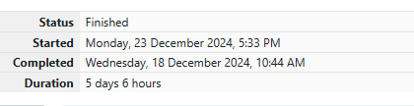
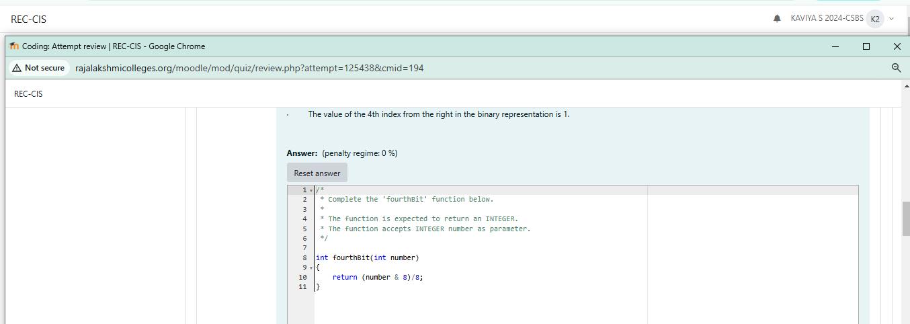
OUTPUT:
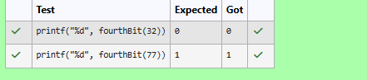
QUESTION 2:
Determine the factors of a number (i.e., all positive integer values that evenly divide into a number) and then return the p th element of the list, sorted ascending. If there is no p th element, return 0. Example n = 20 p = 3 The factors of 20 in ascending order are {1, 2, 4, 5, 10, 20}. Using 1-based indexing, if p = 3, then 4 is returned. If p > 6, 0 would be returned.
Sample Case 0 Sample Input 0 STDIN Function ----- -------- 10 → n = 10 3 → p = 3 Sample Output 0 5
Sample Case 1 Sample Input 1 STDIN Function ----- -------- 10 → n = 10 5 → p = 5 106 Sample Output 1 0
PROGRAM:

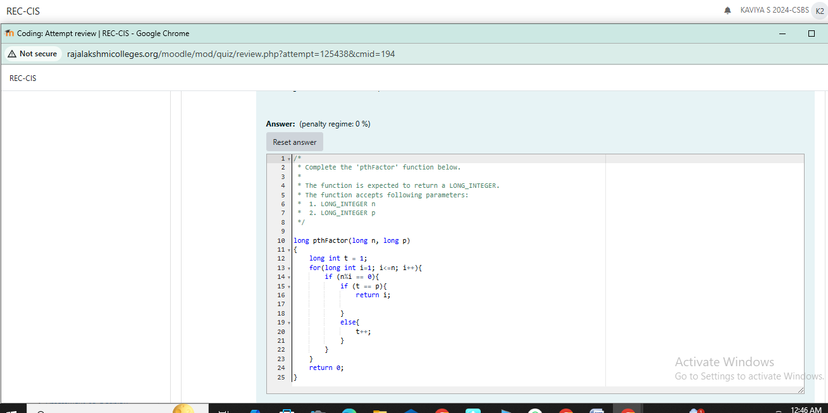
OUTPUT:
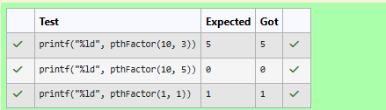
QUESTION 3:
You are a bank account hacker. Initially you have 1 rupee in your account, and you want exactly N rupees in your account. You wrote two hacks, first hack can multiply the amount of money you own by 10, while the second can multiply it by 20. These hacks can be used any number of time. Can you achieve the desired amount N using these hacks. Constraints: 1<=T<=100 1<=N<=10^12 Input • The test case contains a single integer N. Output For each test case, print a single line containing the string "1" if you can make exactly N rupees or "0" otherwise.
SAMPLE INPUT
1
SAMPLE OUTPUT
1
SAMPLE INPUT
2
SAMPLE OUTPUT
0
PROGRAM:
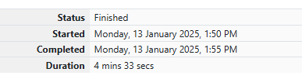
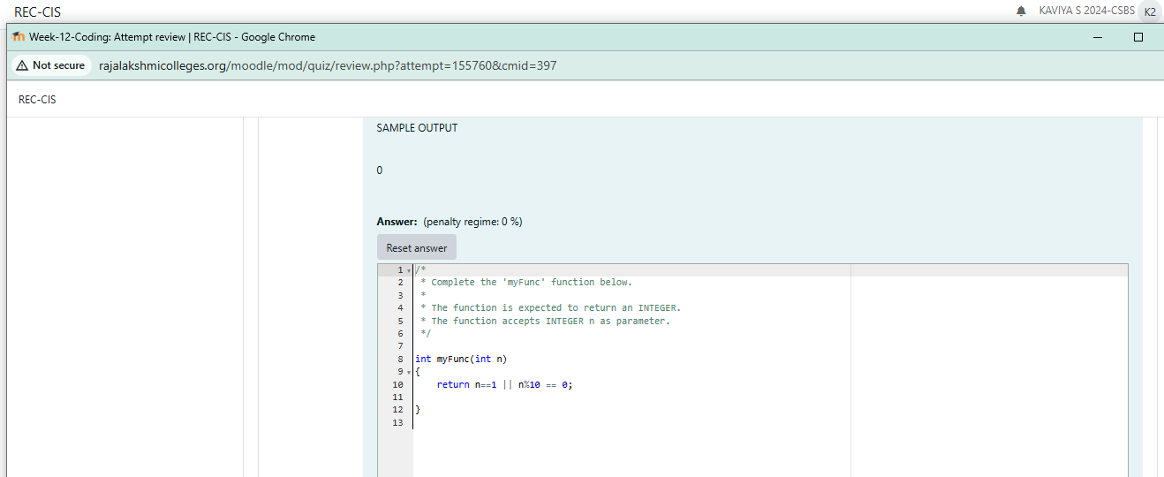

OUTPUT:
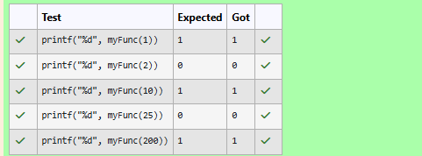
QUESTION 4:
Find the number of ways that a given integer, X, can be expressed as the sum of the Nth powers of unique, natural numbers. For example, if X = 13 and N = 2, we have to find all combinations of unique squares adding up to 13. The only solution is 22 + 32. Function Description Complete the powerSum function in the editor below. It should return an integer that represents the number of possible combinations. powerSum has the following parameter(s): X: the integer to sum to N: the integer power to raise numbers to Input Format The first line contains an integer X. The second line contains an integer N. Constraints 1 ≤ X ≤ 1000 2 ≤ N ≤ 10 Output Format Output a single integer, the number of possible combinations calculated.
Sample Input
10 2
Sample Output
1
PROGRAM:

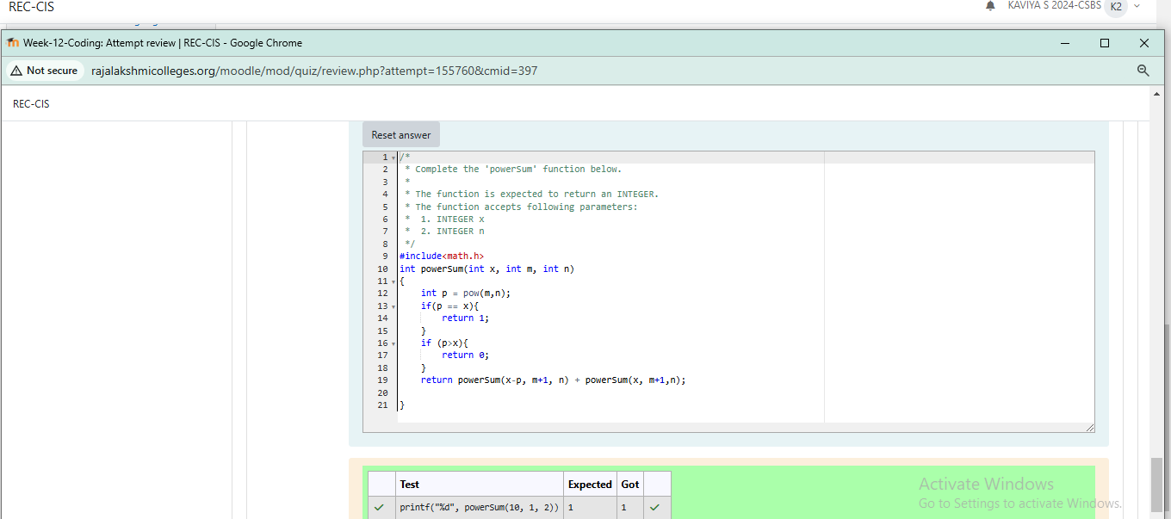
OUTPUT:
